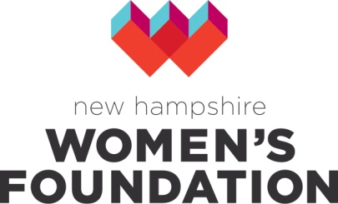
www.nhwomensfoundation.org
2019 Grants Program

Step-by-Step Application Guide

Note: This document is to be used as a template or guide for preparing your online application and is not intended to serve as your application. We suggest you answer the 5 questions below, and then copy and paste your answers into the online application. Because there is not a log-in feature, once you begin the online application, you must complete it and submit it – there is no ability to save your work and work on it at a later time. So create your answers here to avoid losing any of your work.

Once you have written your answers, please copy and paste to your online applications at our online grant portal. If you have any questions about this process, please contact Allison Hawkins or call 603.226.3355.

Step One: Make sure you are eligible to apply by reviewing who and what we fund on the Apply for a Grant page.

Step Two: Answer the 5 questions below about your application, being sure to stay within the word limits.

- Project Executive Summary (100 words): Please briefly describe your project, its importance and the results you expect from this work. Please indicate what the funding will be used for, and the number of people impacted.

- Need (250 words): Describe the need or opportunity (community or organizational) for your proposed work. Why is now a strategic time for the Foundation to invest in this work?

- Project Description (250 words): Briefly describe the project/proposed work, including major activities, timetable and staff qualifications related to the work.

- Results (250 words): If your project is successful, what will be different as a result of your work? What outcomes do you expect? How will you track them?

- Sustainability (150 words): If this work is ongoing, how will you sustain the work beyond this grant? If it is not ongoing, how does it advance organizational goals and produce significant community benefit?

Step Three: Complete the online application, which has 4 parts:

- Applicant information (basic information about your organization)
- Narrative (the 5 questions listed above)
- Required Attachments
  - Project Budget (Only needed if you are applying for project funding. If you are applying for operating support, this is not needed.)
  - Operational Budget
  - IRS 501©3 letter
  - List and brief description of board members and their affiliations
- Submit button – when all the information is complete

Please note: You should receive a confirmation email when you submit your application, stating that your application has been successfully submitted. If you don’t receive one, please contact us.

Step Four: Watch for an email notifying you of the status of your application by Late June.

Step Five: If you receive a grant, you will be required to submit a final grant report within one year of receiving funding. We will also share photos of your work with our supporters.

Questions? Contact Allison Hawkins – allison@nhwomensfoundation.org
or call 603.226.3355.

